Payments Received report

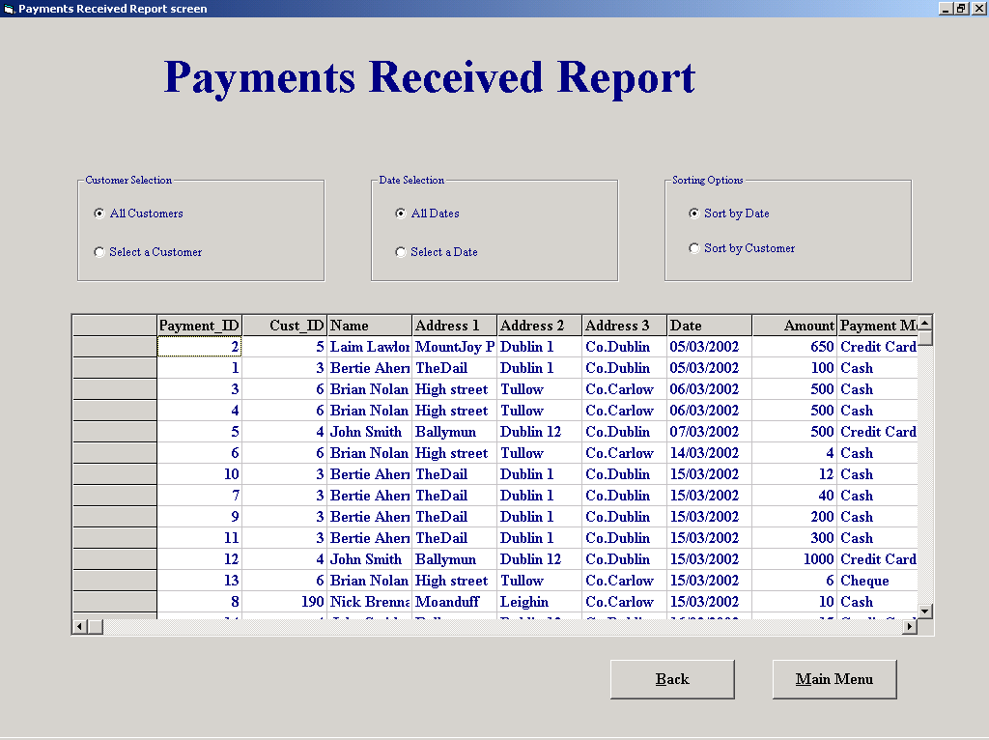

'Purpose This form allows the user to Display a number of different Reports
' depending on the options selected
'Student David Hamilton
'StudentID Com2023
'Last Modified 15/3/02

'Variables used
'strName String
'strID String
'intNumber Integer
'intID Integer
'intResponse Integer
'dateDate Date
'sqlDescription String

Option Explicit

Private Sub cboName_Click()
cmdSeekCustomer.Enabled = True

End Sub

'Returns to the reports menu
Private Sub cmdBack_Click()
frmReportsMenu.Show
Unload Me
End Sub

'Runs the function "functSQL" which selects the appropiate sql statement
'and returns the value to the data grid
Private Sub cmdConfirm_Click()

datGrid.RecordSource = functSQL
datGrid.Refresh
EnableOptions
fmeName.Visible = False
frmConfirm.Visible = False

End Sub

'A function to enable the select and sort option buttons
Private Sub EnableOptions()

optAllDates.Enabled = True
optAllCust.Enabled = True
optSelectCust.Enabled = True
optDateSort.Enabled = True
optCustomerSort.Enabled = True
optSelectDate.Enabled = True
End Sub
'Runs the function "functSQL" which selects the appropiate sql statement
'and returns the value to the data grid

Private Sub cmdConfirmDate_Click()

datGrid.RecordSource = functSQL
datGrid.Refresh
EnableOptions
fmeDate.Visible = False

End Sub

Private Sub cmdMainMenu_Click()
frmMainMenu.Show
Unload Me
End Sub

'Runs the function "functSQL" which selects the appropiate sql statement
'and returns the value to the data grid
Private Sub optAllCust_Click()

datGrid.RecordSource = functSQL
datGrid.Refresh
End Sub
'Runs the function "functSQL" which selects the appropiate sql statement
'and returns the value to the data grid
Private Sub optAllDates_Click()

datGrid.RecordSource = functSQL
datGrid.Refresh
End Sub

'Runs the function "functSQL" which selects the appropiate sql statement
'and returns the value to the data grid
Private Sub optCustomerSort_Click()

datGrid.RecordSource = functSQL
datGrid.Refresh
End Sub

'Runs the function "functSQL" which selects the appropiate sql statement
'and returns the value to the data grid
Private Sub optDateSort_Click()

datGrid.RecordSource = functSQL
datGrid.Refresh
End Sub

Private Sub optName_Click()

lblNameNumber = "Enter Customers Name"
cboName = ""
cboName.Visible = True
cboNumber.Visible = False
cboName.SetFocus

End Sub

Private Sub optNumber_Click()

cboNumber.Text = cboNumber.List(0)
lblNameNumber = "Enter Customers ID Number"
cboName.Visible = False
cboNumber.Visible = True
cboNumber = ""
cboNumber.Enabled = True

End Sub

Private Sub cboName_Change()
cboName_Click
End Sub

'This function checks to see which search and sort options have been selected
'then selects the correct SQL querry
Private Function functSQL() As String
Dim dateDate As Date
Dim intID As Integer

If Not optAllDates Then
dateDate = Format(calCalander.Value, "mm dd yyyy")
End If
If Len(cboNumber.Text) <> 0 Then
intID = Val(cboNumber.Text)
End If

If optAllCust = True And optAllDates = True And optDateSort = True Then
functSQL = "SELECT Payment.Payment_ID, Customer.Cust_ID, Customer.Name, Customer.[Address 1], Customer.[Address 2], Customer.[Address 3], Payment.Date, Payment.Amount, Payment.[Payment Method] FROM Customer INNER JOIN Payment ON Customer.Cust_ID = Payment.Cust_ID ORDER BY Payment.Date;"
ElseIf optAllCust = False And optAllDates = True And optDateSort = True Then
functSQL = "SELECT Payment.Payment_ID, Customer.Cust_ID, Customer.Name, Customer.[Address 1], Customer.[Address 2], Customer.[Address 3], Payment.Date, Payment.Amount, Payment.[Payment Method] FROM Customer INNER JOIN Payment ON Customer.Cust_ID = Payment.Cust_ID WHERE Customer.Cust_ID = " & intID & " ORDER BY Payment.Date;"
ElseIf optAllCust = False And optAllDates = False And optDateSort = True Then
functSQL = "SELECT Payment.Payment_ID, Customer.Cust_ID, Customer.Name, Customer.[Address 1], Customer.[Address 2], Customer.[Address 3], Payment.Date, Payment.Amount, Payment.[Payment Method] FROM Customer INNER JOIN Payment ON Customer.Cust_ID = Payment.Cust_ID WHERE Customer.Cust_ID = " & intID & " AND Payment.Date = #" & dateDate & "# ORDER BY Payment.Date;"
ElseIf optAllCust = False And optAllDates = False And optDateSort = False Then
functSQL = "SELECT Payment.Payment_ID, Customer.Cust_ID, Customer.Name, Customer.[Address 1], Customer.[Address 2], Customer.[Address 3], Payment.Date, Payment.Amount, Payment.[Payment Method] FROM Customer INNER JOIN Payment ON Customer.Cust_ID = Payment.Cust_ID WHERE Customer.Cust_ID = " & intID & " AND Payment.Date = #" & dateDate & "# ORDER BY Customer.Name;"
ElseIf optAllCust = False And optAllDates = True And optDateSort = False Then
functSQL = "SELECT Payment.Payment_ID, Customer.Cust_ID, Customer.Name, Customer.[Address 1], Customer.[Address 2], Customer.[Address 3], Payment.Date, Payment.Amount, Payment.[Payment Method] FROM Customer INNER JOIN Payment ON Customer.Cust_ID = Payment.Cust_ID WHERE Customer.Cust_ID = " & intID & " ORDER BY Customer.Name;"
ElseIf optAllCust = True And optAllDates = True And optDateSort = False Then
functSQL = "SELECT Payment.Payment_ID, Customer.Cust_ID, Customer.Name, Customer.[Address 1], Customer.[Address 2], Customer.[Address 3], Payment.Date, Payment.Amount, Payment.[Payment Method] FROM Customer INNER JOIN Payment ON Customer.Cust_ID = Payment.Cust_ID ORDER BY Customer.Name;"
ElseIf optAllCust = True And optAllDates = False And optDateSort = True Then
functSQL = "SELECT Payment.Payment_ID, Customer.Cust_ID, Customer.Name, Customer.[Address 1], Customer.[Address 2], Customer.[Address 3], Payment.Date, Payment.Amount, Payment.[Payment Method] FROM Customer INNER JOIN Payment ON Customer.Cust_ID = Payment.Cust_ID WHERE Payment.Date = #" & dateDate & "# ORDER BY Payment.Date;"
Else
functSQL = "SELECT Payment.Payment_ID, Customer.Cust_ID, Customer.Name, Customer.[Address 1], Customer.[Address 2], Customer.[Address 3], Payment.Date, Payment.Amount, Payment.[Payment Method] FROM Customer INNER JOIN Payment ON Customer.Cust_ID = Payment.Cust_ID WHERE Payment.Date = #" & dateDate & "# ORDER BY Customer.Name;"
End If
End Function
'Ensures that the cboName input section has been filled

Private Sub cboName_Validate(Cancel As Boolean)
Dim intResponse As Integer

If Len(cboName.Text) = 0 Then
Cancel = True
intResponse = MsgBox("You must enter data into this field", vbOKOnly, "Please Enter Data")
If intResponse = 1 Then
cboName.SetFocus
End If

End If
End Sub

Private Sub cboNumber_Change()
cmdSeekCustomer.Enabled = True
End Sub

Private Sub cboNumber_Click()
cmdSeekCustomer.Enabled = True

End Sub

'Using the Name/Number/letters entered a search is made of the
'Customer Table to return the first match, the coresponding
'record is then displayed. If a search is made using a name
'and their is more than one match, the user is then allowed
'step through the records of those with matching names
Private Sub cmdSeekCustomer_Click()
Dim strName, strID As String
Dim intNumber, intID As Integer

cmdPrevious.Enabled = True
cmdNext.Enabled = True

strID = cboName.Text

sqlCount = "SELECT Count(*)AS IDCount FROM Customer WHERE Name Like '*" & strID & "*';"

datSQL1.DatabaseName = "G:\EqpthireProject\EHS.mdb"
datSQL1.RecordSource = sqlCount
datSQL1.Refresh

intCount = datSQL1.Recordset.Fields("IDCount")

If intCount > 1 Then 'Displays matching records if their is more than 1
fmeMove.Visible = True
txtMatches = intCount
cmdPrevious.Enabled = True
cmdNext.Enabled = True
End If
If optName = True Then
strName = cboName.Text
If Not Len(strName) = 0 Then
datCustomer.Recordset.FindFirst "Name like '*" & strName & "*'"

cboNumber.Text = datCustomer.Recordset("Cust_ID")
txtNameFound = datCustomer.Recordset("Name")
txtAddress1 = datCustomer.Recordset("Address 1")
txtAddress2 = datCustomer.Recordset("Address 2")
txtAddress3 = datCustomer.Recordset("Address 3")

End If
Else
intNumber = Int(Val(cboNumber.Text))

datCustomer.Recordset.FindFirst "Cust_ID = " & intNumber & ""

txtNameFound = datCustomer.Recordset("Name")
txtAddress1 = datCustomer.Recordset("Address 1")
txtAddress2 = datCustomer.Recordset("Address 2")
txtAddress3 = datCustomer.Recordset("Address 3")

End If
frmConfirm.Visible = True 'A confirm option is used to ensure that the correct
'information has been selected

End Sub

'This only becomes visable if there is a match in names selected and allows you to
'move forward through each possible customer until you can confirm you have
'the correct one from the extra details shown
Private Sub cmdNext_Click()
Dim strName As String

strName = cboName.Text
With datCustomer.Recordset
.FindNext ("Name like '*" & strName & "*'")

End With
cboNumber.Text = datCustomer.Recordset("Cust_ID")
txtNameFound = datCustomer.Recordset("Name")
txtAddress1 = datCustomer.Recordset("Address 1")
txtAddress2 = datCustomer.Recordset("Address 2")
txtAddress3 = datCustomer.Recordset("Address 3")

End Sub
'This only becomes visable if there is a match in names selected and allows you to
'move backwards through each possible customer until you can confirm you have
'the correct one from the extra details shown
Private Sub cmdPrevious_Click()
Dim strName As String

strName = cboName.Text
With datCustomer.Recordset
.FindPrevious ("Name like '*" & strName & "*'")

End With
cboNumber.Text = datCustomer.Recordset("Cust_ID")
txtNameFound = datCustomer.Recordset("Name")
txtAddress1 = datCustomer.Recordset("Address 1")
txtAddress2 = datCustomer.Recordset("Address 2")
txtAddress3 = datCustomer.Recordset("Address 3")

End Sub
'Fills the customer name and id number combo box's with information stored in the
'Customer table also an SQL query which is correct for the initial set up of
'the option buttons is run and the Data Grid is filled

Private Sub Form_Load()
Dim sqlDescription As String
cboName.Text = cboName.List(0)
datCustomer.DatabaseName = "G:\EqpthireProject\EHS.mdb"
datCustomer.RecordSource = "Customer"
datCustomer.Refresh

While Not datCustomer.Recordset.EOF
cboName.AddItem datCustomer.Recordset("Name")
cboNumber.AddItem datCustomer.Recordset("Cust_ID")
datCustomer.Recordset.MoveNext
Wend

sqlDescription = "SELECT Payment.Payment_ID, Customer.Cust_ID, Customer.Name, Customer.[Address 1], Customer.[Address 2], Customer.[Address 3], Payment.Date, Payment.Amount, Payment.[Payment Method] FROM Customer INNER JOIN Payment ON Customer.Cust_ID = Payment.Cust_ID ORDER BY Payment.Date;"

datGrid.DatabaseName = "G:\EqpthireProject\EHS.mdb"
datGrid.RecordSource = sqlDescription
datGrid.Refresh

datGrid.Refresh
End Sub
'Disables all the options while a selection process is taking place
Private Sub DisableOptions()

optAllDates.Enabled = False
optAllCust.Enabled = False
optSelectDate.Enabled = False
optSelectCust.Enabled = False
optDateSort.Enabled = False
optCustomerSort.Enabled = False

End Sub

Private Sub optSelectCust_Click()

DisableOptions
fmeName.Visible = True

End Sub

Private Sub optSelectDate_Click()

DisableOptions
fmeDate.Visible = True

End Sub

